Rukayat Oyeleke 00001539123

DDD

a)

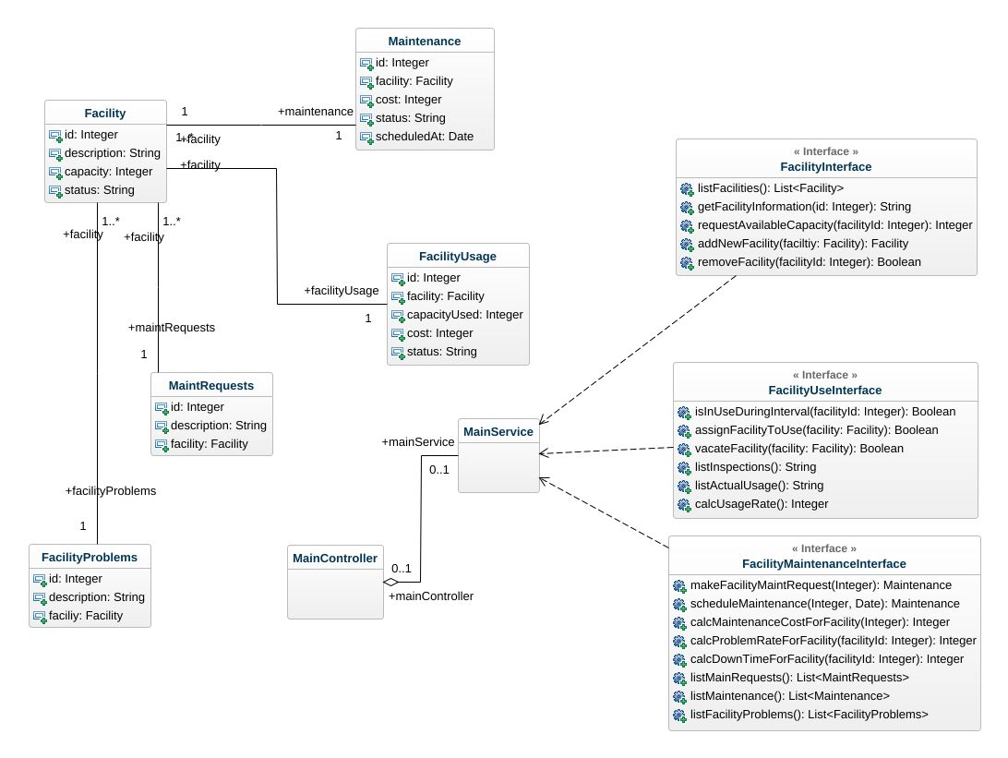

1) Following are the Entities:

* + 1. Facility
    2. FacilityProblems
    3. MaintRequests
    4. FacilityUsage
    5. Maintenance

Facility is a value object that is being used in those entities except for Facility.

2) Following classes has the aggregation which is also defined at “has a” relationship:

1. Maintenance
2. FacilityProblems
3. FacilityUsage
4. MaintRequests
5. MainController

3) MainController, MainService and Three interfaces (FacilityInterface, FacilityUseInterface and FacilityMaintenanceInterface) could be considered as Bound Context as the Service will implement the methods of the interfaces and MainController will user the service to perform db operations.

b) Following is the example of Value Objects and Entities

class Person {

SocialSecurtiyNumber number;

FirstName firstName;

LastName lastName;

Address address;

}

class SocialSecurityNumber {

Integer id;

}

class FirstName {

String firstName;

}

class LastName {

String lastName;

}

class Address {

String houseNo;

String streetNo;

String city;

String postalCode;

}

Second example:

class Employee{

EmployeeId id;

Department department;

Role role;

Salary salary;

}

class EmployeeId{

Integer id;

}

class Department{

String department;

}

class Role{

String role;

}

class Salary{

Double salary;

}